**Question -1**

**/*..WAP to print any message on the screen.....*/**

**#include<stdio.h>**

**#include<conio.h>**

**void main()**

**{**

**printf("My name is Rishi singh.");**

**getch();**

**}**

**Output:**

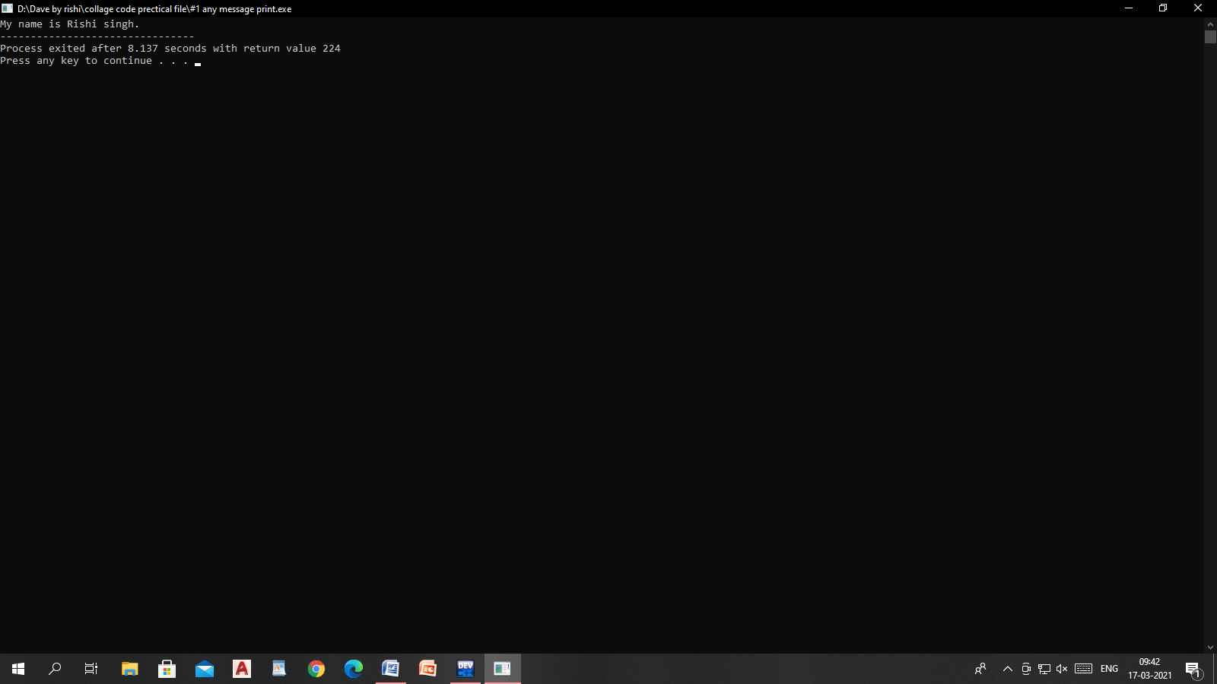

**Question-2**

**/*..WAP to input 2 no's from the user & do their addition, subtraction, multiplication & division......*/**

**#include<stdio.h>**

**#include<conio.h>**

**void main()**

**{**

**int a,b;**

**float x,y;**

**printf("Enter any two number.");**

**scanf("%d%d",&a,&b);**

**printf("add=%d;\nsubtraction=%d;\nmultiplication=%d;\n",a+b,a-b,a*b);**

**printf("\nEnter any two number for division\n");**

**scanf("%f%f",&x,&y);**

**printf("Dvision=%f",x/y);**

**getch();**

**}**

**output:-**

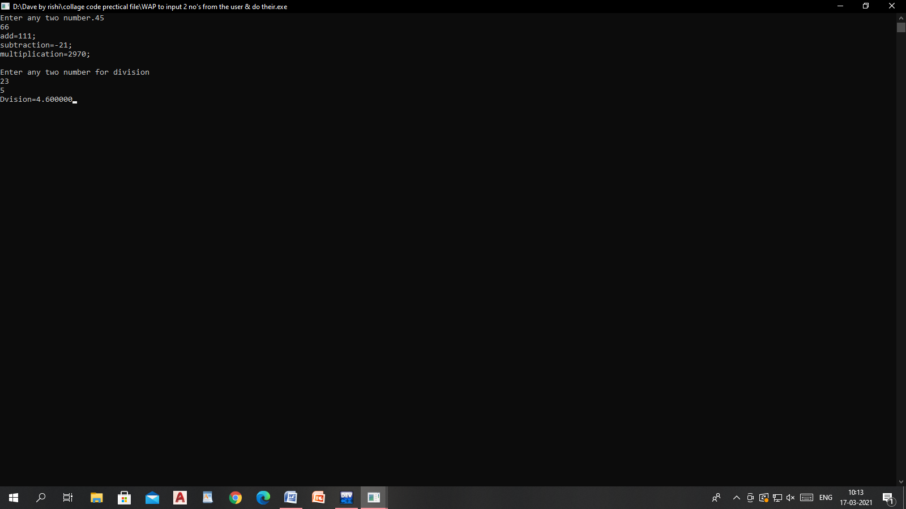

**Question- 3**

**/*..WAP to input principal, rate, time and find the simple interest.....*/**

**#include<stdio.h>**

**#include<conio.h>**

**void main()**

**{**

**int p,i,n,SI;**

**/*..Simple Interest = (P × R × T)/100**

**Where P = Principal Amount, R = Rate per Annum, T = Time (years) ...*/**

**printf("Enter :\nprincipal(P);\nrate(I);\ntime(N)\n");**

**scanf("%d%d%d",&p,&i,&n);**

**SI=(p*i*n)/100;**

**printf("Simpal interest=%d",SI);**

**getch();**

**}**

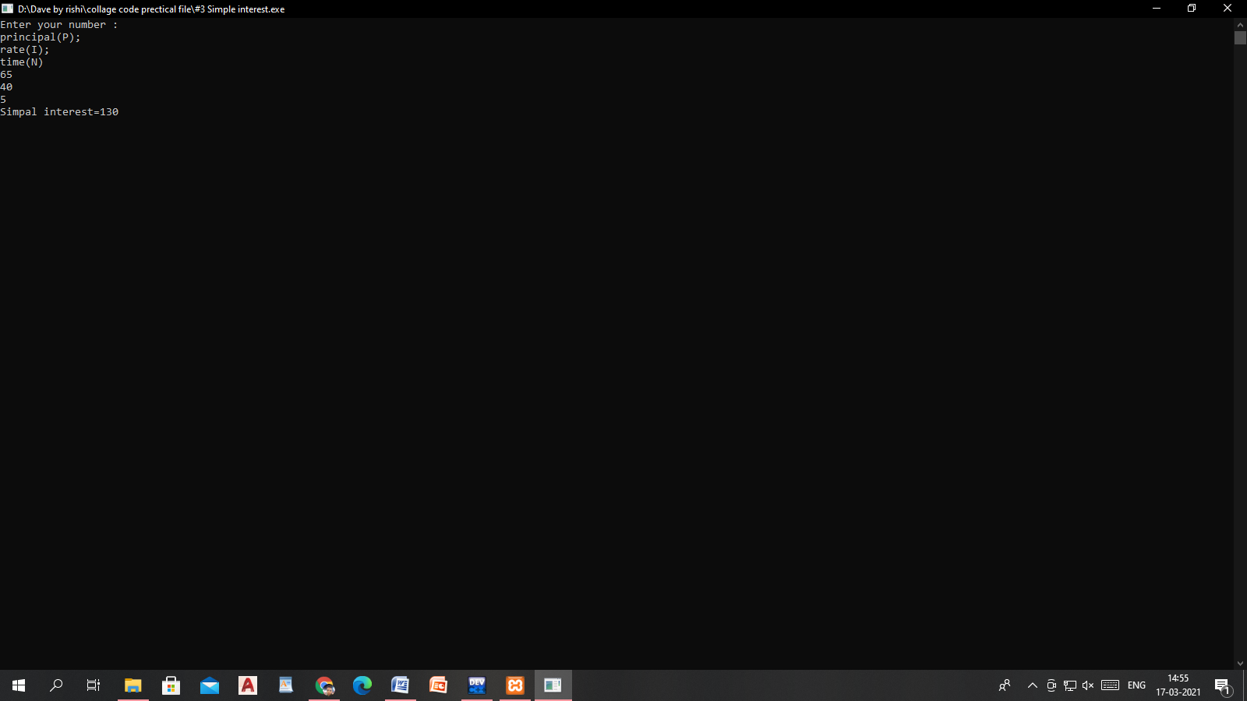

**Question-4**

**/*..WAP to input area of circle, rectangle & square.....*/**

**/*Rectangle Area = l × w L = length \ w = width**

**Square Area = a^2 a = sides of square**

**Circle Area = phi*r^2 r = radius of circle*/**

**#include<stdio.h>**

**#include<conio.h>**

**void main()**

**{**

**int r,l,w,S,R;**

**float C,phi=3.14;**

**printf("Enter your number for -\nArea of Circle.\nside of Square");**

**scanf("%d",&r);**

**C=phi*r*r;**

**S=r*r;**

**printf("Enter your number for Rectangle: \nl=length, w=width\n");**

**scanf("%d%d",&l,&w);**

**R=l*w;**

**printf("Area of circle=%f\n, Square=%d\n, Rectangle=%d\n",C,S,R);**

**getch();**

**}**

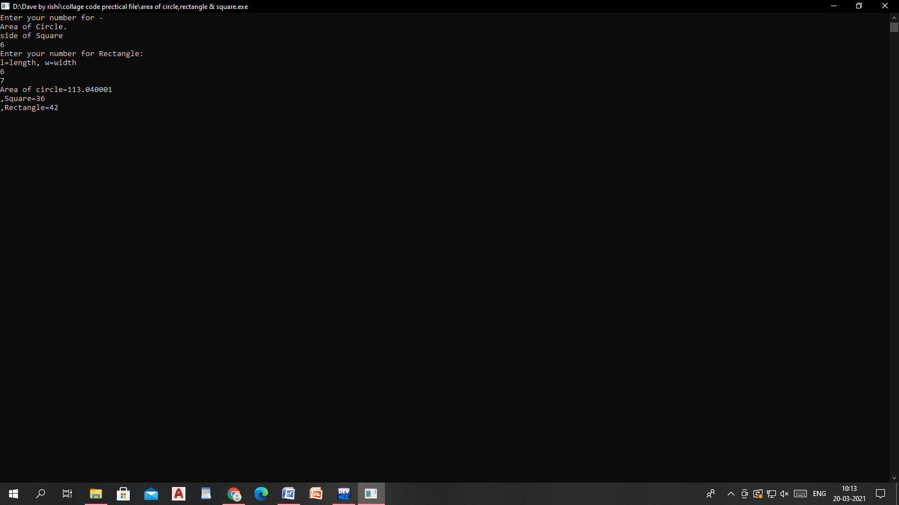

***Question-5***

***/*..WAP to enter marks of a student in 5 subjects & calculate the percentage….*/***

**#include<stdio.h>**

**#include<conio.h>**

**int main()**

**{**

**int cp,math,bc,pom,cf;**

**float p;**

**printf("Enter your 5 subject marks:\n each subject contain 100 marks:\n");**

**scanf("%d%d%d%d%d",&cp,&math,&bc,&pom,&cf);**

**p=(cp+math+bc+pom+cf)/5;**

**printf("parsent=%f\n",p);**

**if(p>60)**

**{**

**printf("\ngread 1st division\n");**

**}**

**else if(p>60 && p<50)**

**{**

**printf("\ngread 2nd division\n");**

**}**

**else if(p>50 && p<40)**

**{**

**printf("\ngread 3rd division\n");**

**}**

**else**

**printf("\nyou are fail\n");**

**getch();**

**}**

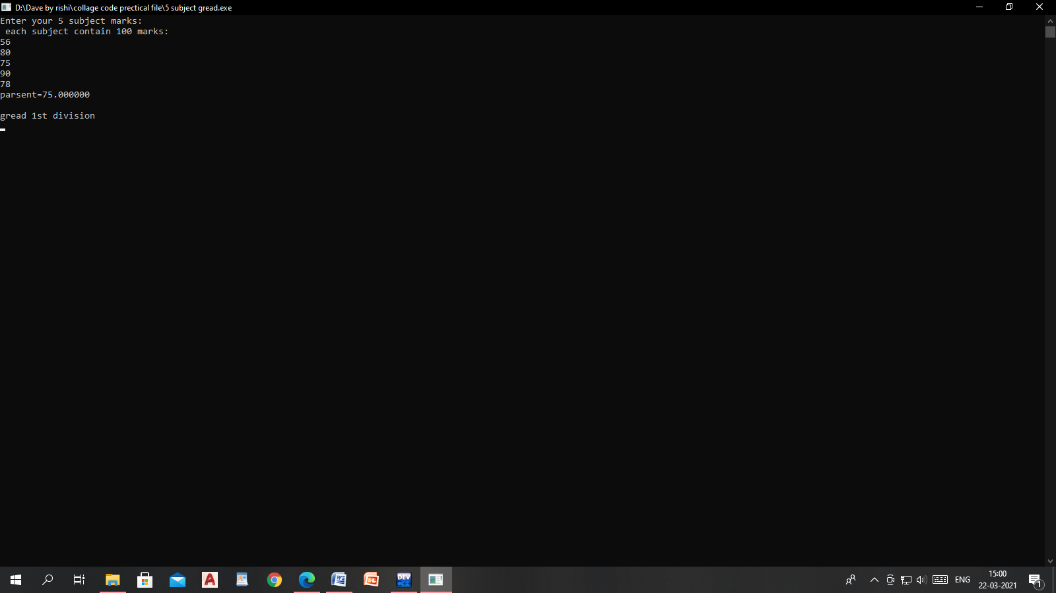

**Question-6**

***/*…..WAP to find average of 7 numbers……..*/***

**/*..WAP to find average of 7 numbers.......*/**

**#include<stdio.h>**

**#include<conio.h>**

**int main()**

**{**

**int a,b,c,d,f,g,h;**

**float A;**

**printf("Enter your number for find Average.");**

**scanf("%d%d%d%d%d%d%d",&a,&b,&c,&d,&f,&g,&h);**

**A=(a+b+c+d+f+g+h)/7;**

**printf("Average of 7 number=%f",A);**

**}**

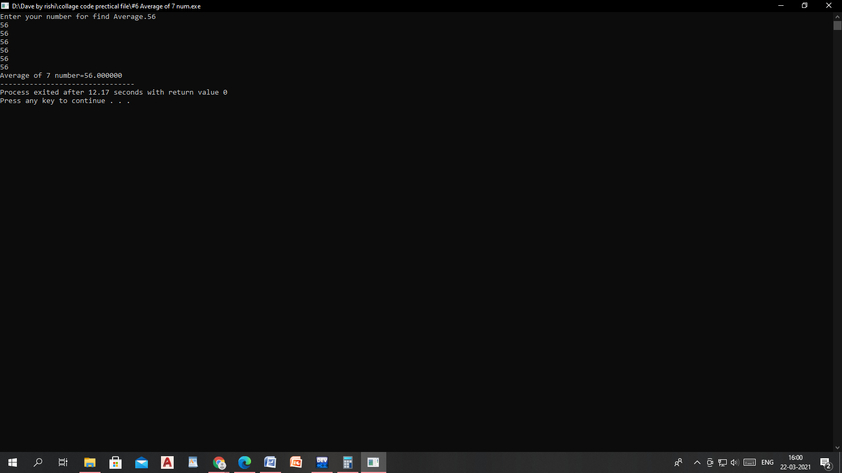

***Question-7***

***/*...WAP to calculate***

***i=(a+b)^2***

***ii=(a+b)^3***

***iii=(a^2-b^2).........*/***

**#include<stdio.h>**

**#include<conio.h>**

**void main()**

**{**

**int a,b,A,B,C;**

**printf("Enter your number:");**

**scanf("%d%d",&a,&b);**

**A=(a+b)*(a+b);**

**B=(a+b)*(a+b)*(a+b);**

**C=(a*a-b*b);**

**printf("i=(a+b)^2 =%d\n,(a+b)^3=%d\n,(a^2-b^2)=%d\n",A,B,C);**

**getch();**

**}**

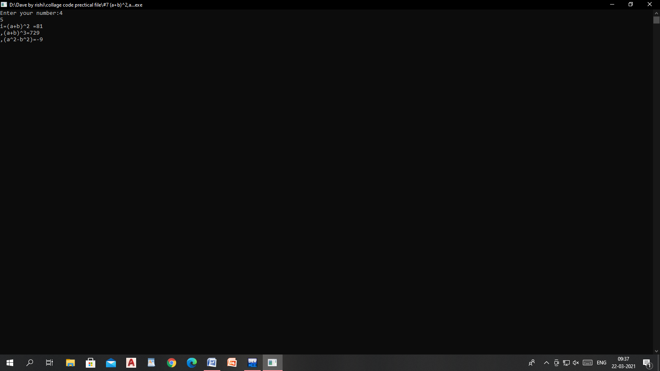

***Question-8***

***/*…..WAP to find circumference of a circle………*/***

**#include<stdio.h>**

**int main()**

**{**

**int r;**

**float c;**

**printf("Enter radius of the circle:");**

**scanf("%d",&r);**

**c=2*3.14*r;**

**printf("circumference=%f\n",c);**

**return 0;**

**}**

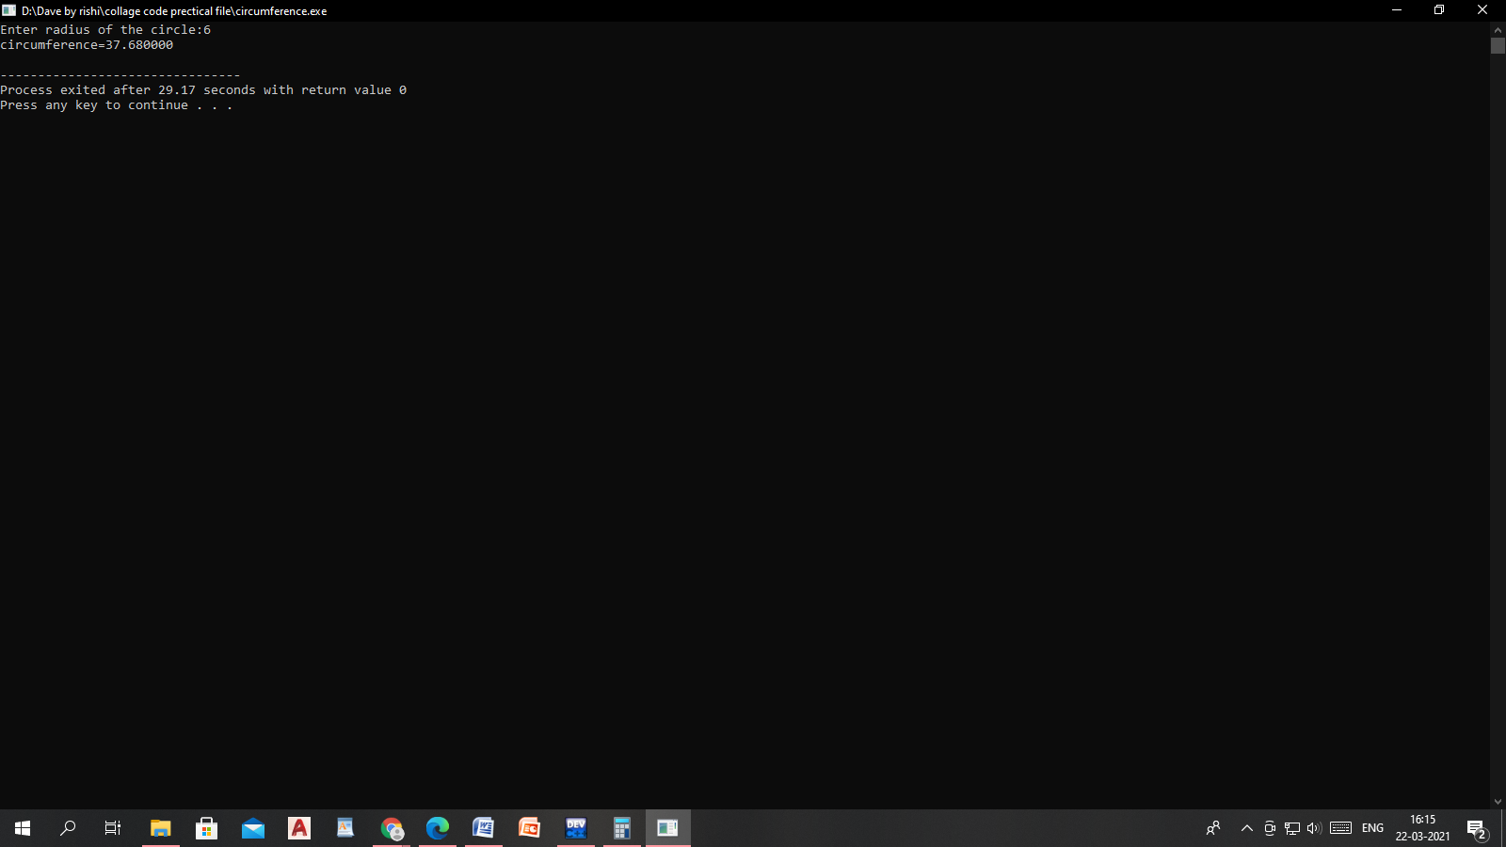

Question-9

**/*...WAP to swap 2 no’s by using a third variable....*/**

**#include<stdio.h>**

**int main()**

**{**

**int c,a,b;**

**printf("Enter your number:a,b");**

**scanf("%d%d",&a,&b);**

**c=a;**

**a=b;**

**b=c;**

**printf("b=%d, a=%d",b,a);**

**return 0;**

**}**

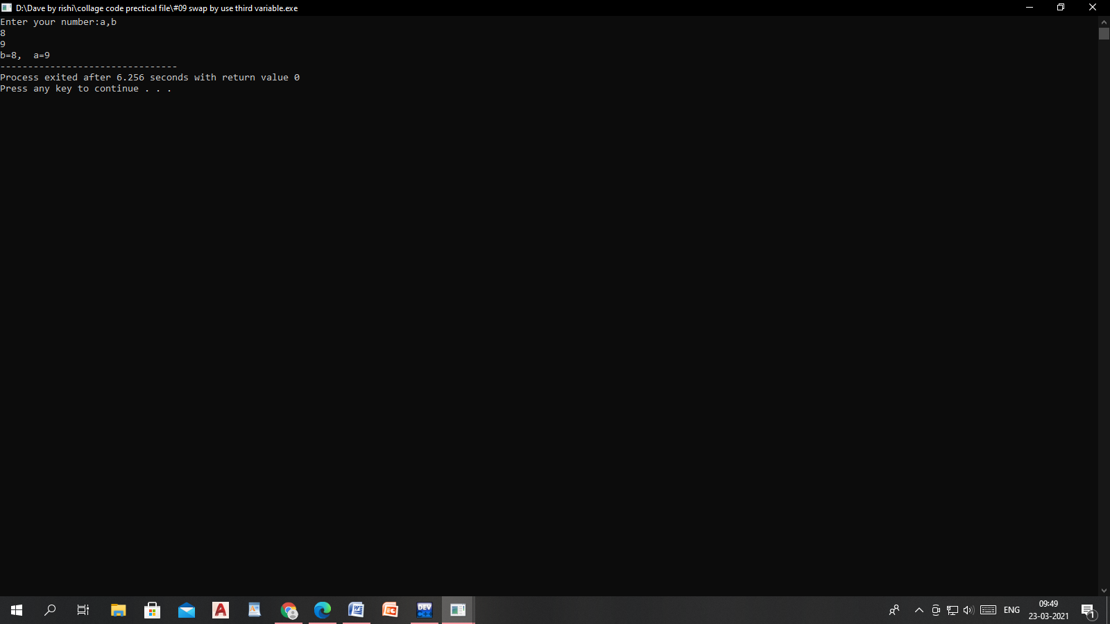

Question-10

/*…WAP to swap 2 no’s without using a third variable…..*/

#include<stdio.h>

int main()

{

int a,b;

printf("Enter your number:a,b");

scanf("%d%d",&a,&b);

a=a+b;

b=a-b;

a=a-b;

printf("b=%d, a=%d",b,a);

return 0;

}

Output:-

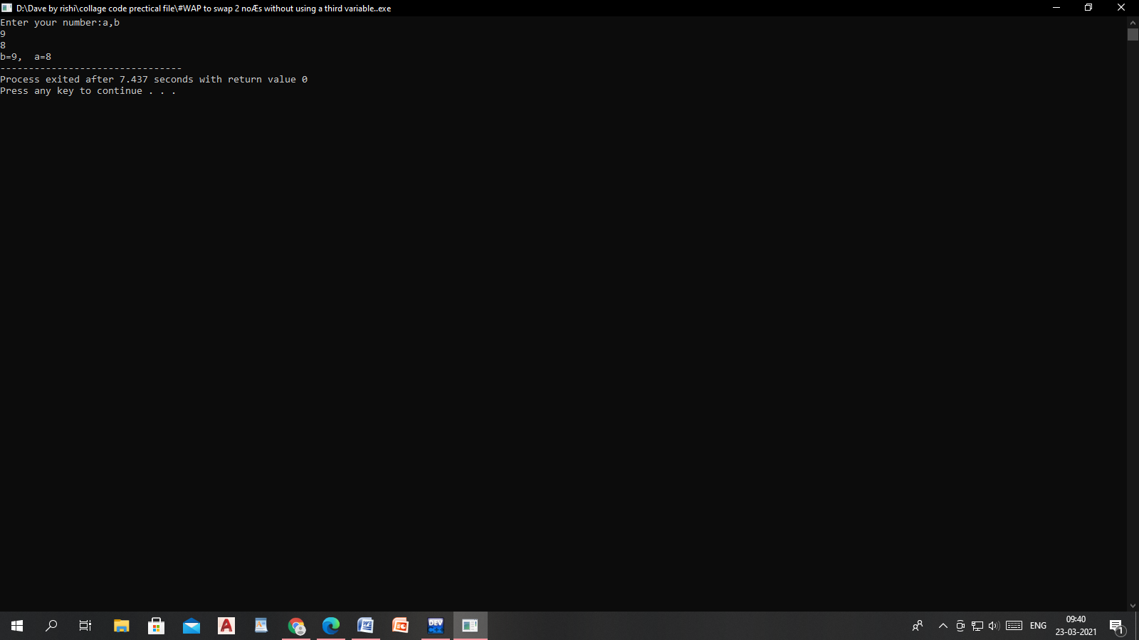

**Question-11**

**/*..WAP to convert temperature from "degree Celsius to Fahrenheit” and vice-versa. Use the formula. ...*/**

**#include<stdio.h>**

**int main()**

**{**

**float tC,tF;**

**printf("Enter your temprature in degree Fahrenheit:\n");**

**scanf("%f",&tC);**

**tF=(tC*9/5)+32.0;**

**printf("\nDegree Celsius to Fahrenheit: %f\n",tF);**

**return 0;**

**}**

**Output:-**

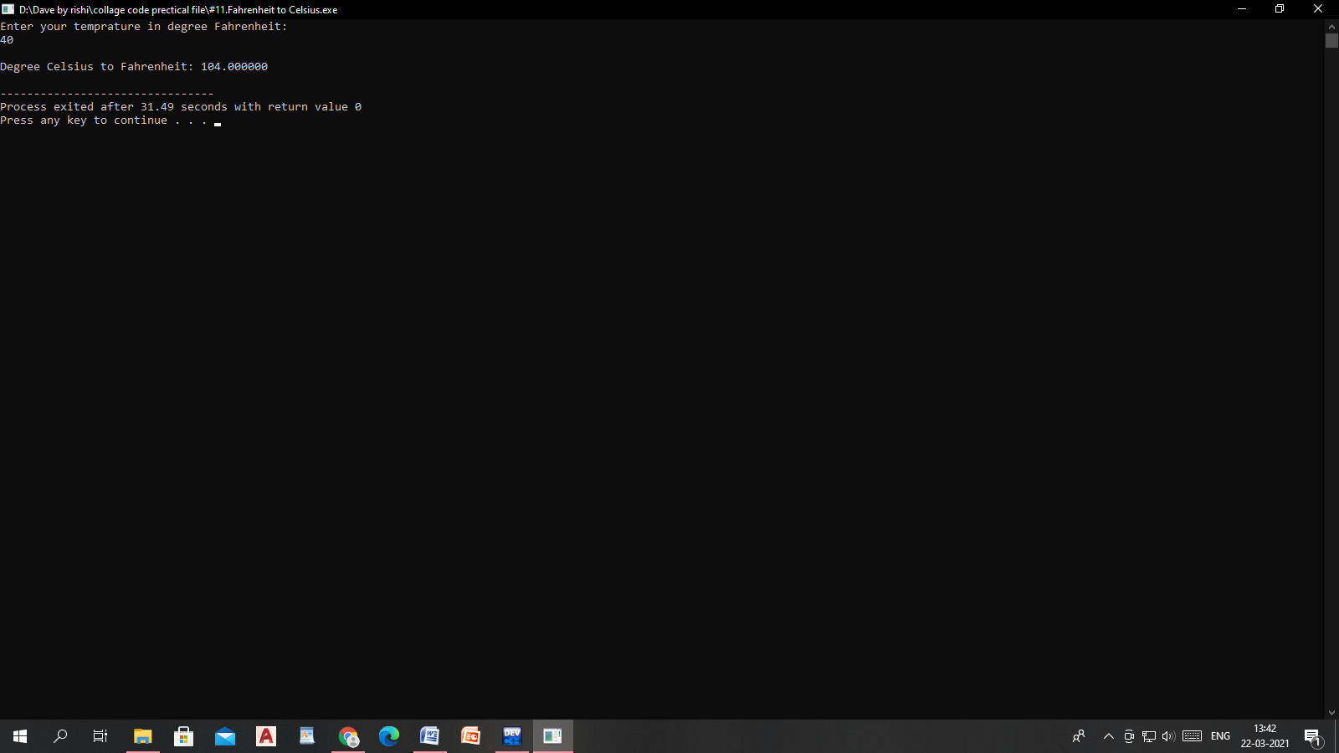

***Question-12***

/*…. WAP to calculate the Gross Salary of an employee. Assume Gross Salary=Basic Salary+DA+HRA DA=40% of Basic Salary HRA=20% of Basic Salary....*/

#include<stdio.h>

int main()

{

int Bs,Gs,Da,Hra;

printf("Enter your Basic salary:");

scanf("%d",&Bs);

Da=Bs*40/100;

Hra=20*20/100;

Gs=Bs+Da+Hra;

printf("Gross salary=%d",Gs);

return 0;

}

Output:-

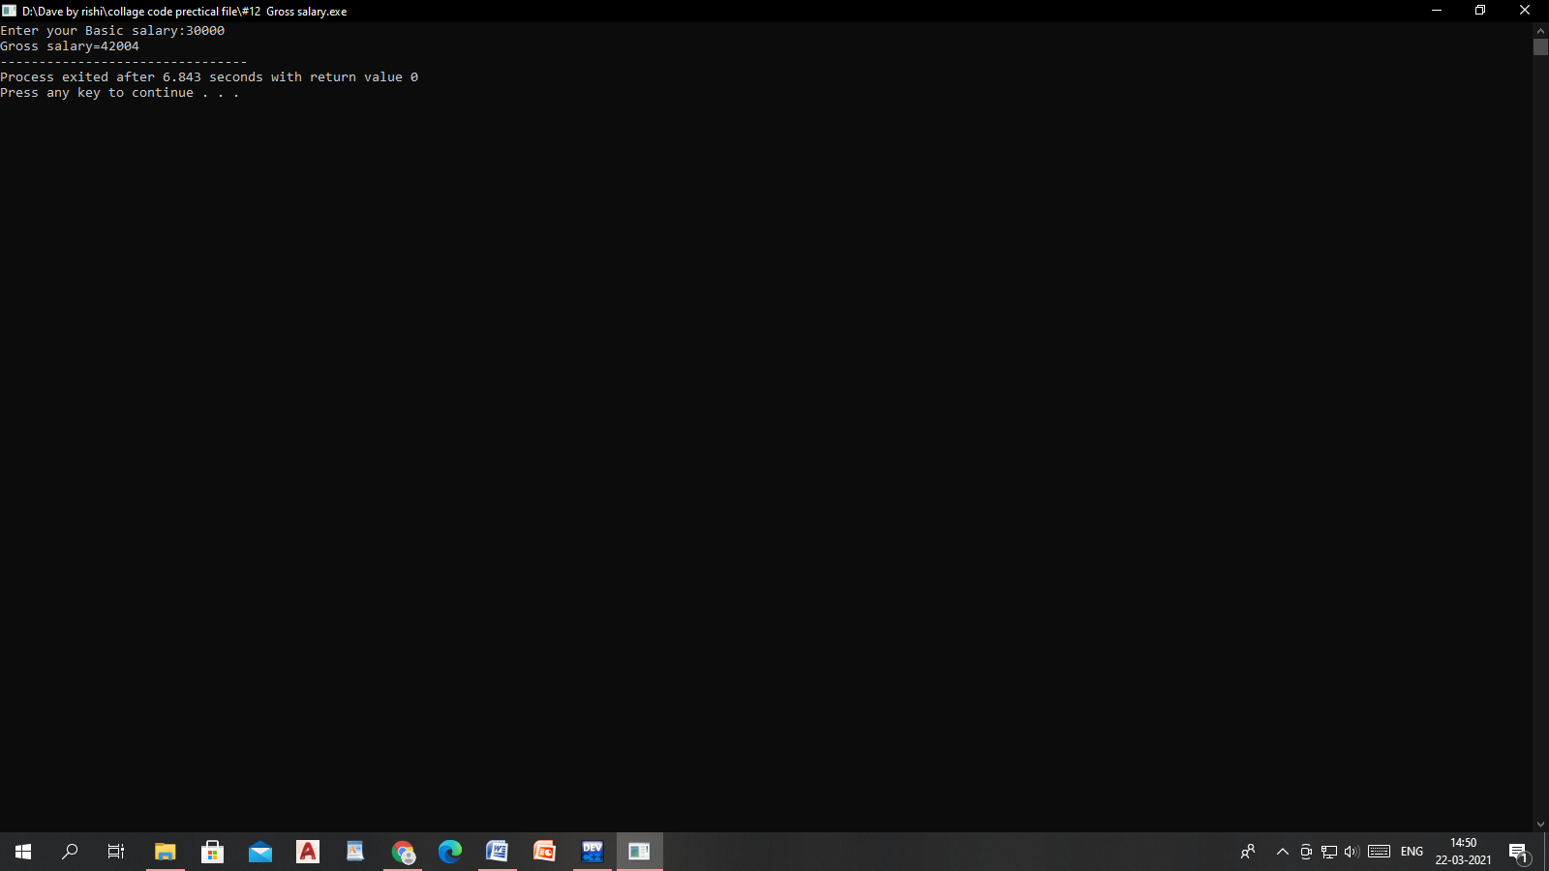

Question-13

/*…….WAP to find whether a person can vote or not……….*/

Solution: 1-

#include<stdio.h>

int main(){

int a;

printf("Enter the value of age.\n");

scanf("%d",&a);

if (a>=18)

printf("you are eligble for vote.\n");

else

printf("You are not eligble for vote.");

return 0;

}

Solution: 2-

Expression1? expression2: expression3;

#include <stdio.h>

int main()

{

int age; // variable declaration

printf("Enter your age");

scanf("%d",&age); // taking user input for age variable

(age>=18)? (printf("eligible for voting")) : (printf("not eligible for voting")); // conditional operator

return 0;

}

Output:-

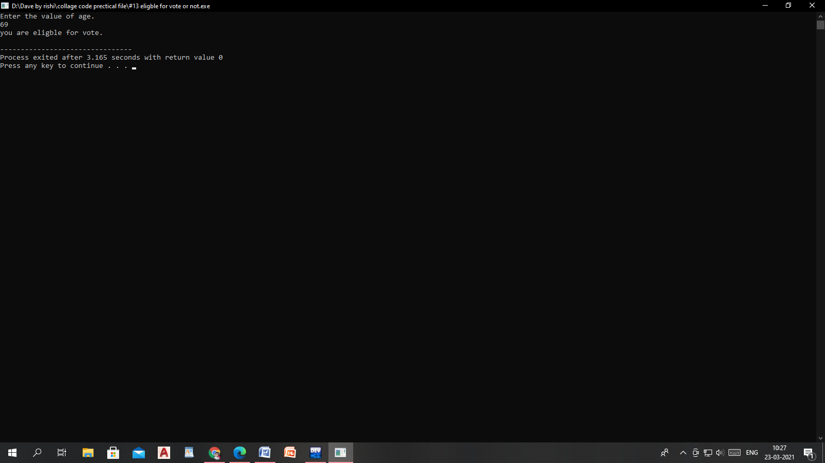

Question-14

/*...Wap to check given number is even or odd......*/

Solution 1:-

#include<stdio.h>

#include<conio.h>

void main()

{

int a;

printf("enter the value of a");

scanf("%d",&a);

if(a%2==0)

{

printf("Even number");

}

else

{

printf("Odd number");

}

getch();

}

Output:-

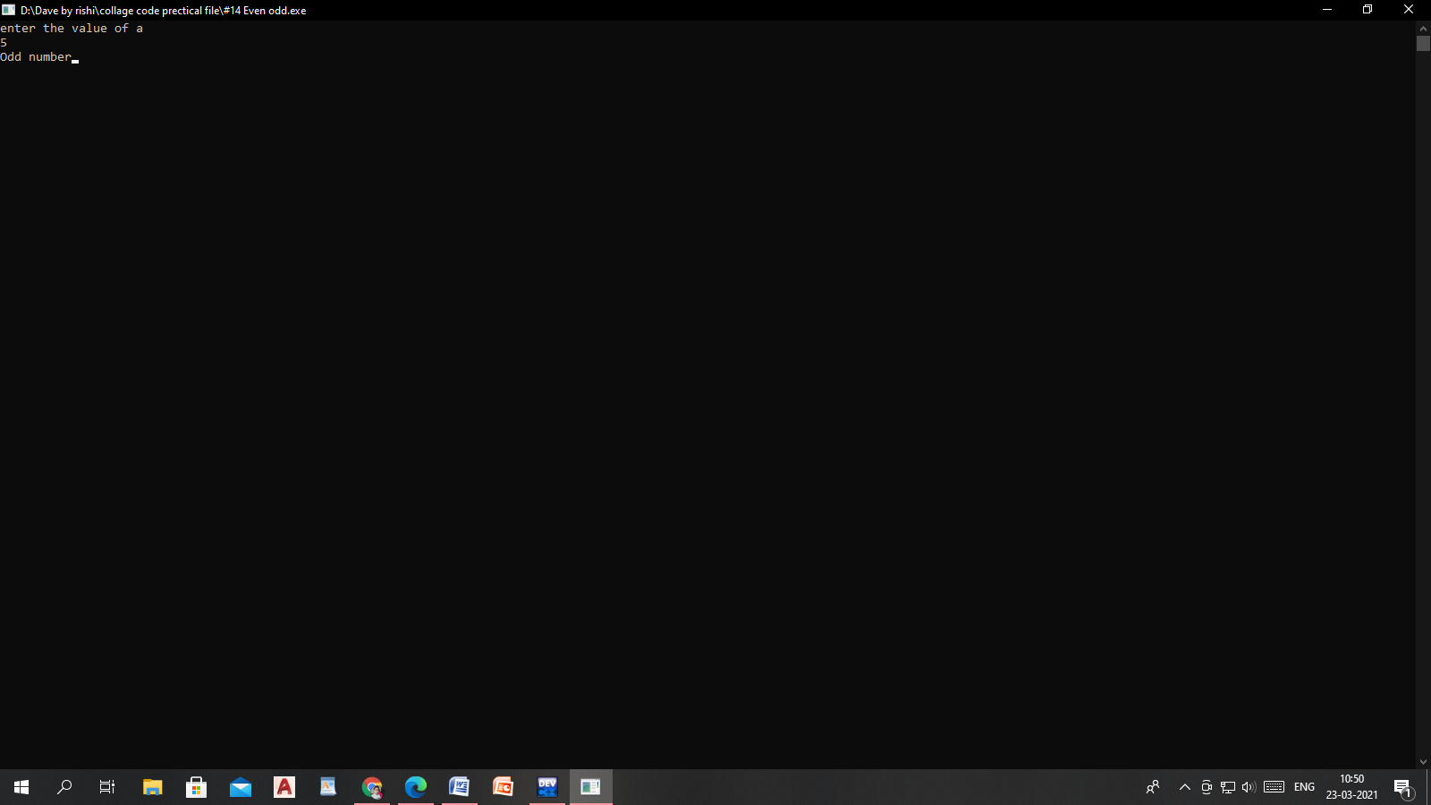

Question-15

/*.....WAP to find whether a no is positive or negative......*/

#include<stdio.h>

#include<conio.h>

void main()

{

int a;

printf("enter the value of a");

scanf("%d",&a);

if (a>0)

{

printf("Number is Positive");

}

else

{

printf("Number is Negative");

}

getch();

}

Output:-

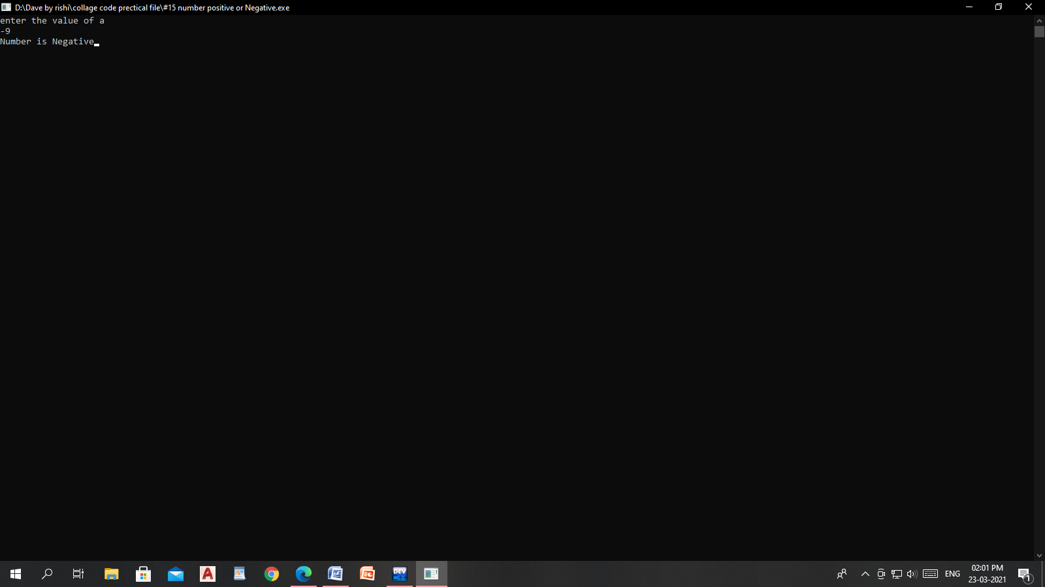

Question-16

/*.....WAP to enter the %age of a student & print whether he is PASS or

FAIL..........*/

#include<stdio.h>

#include<conio.h>

void main()

{

int a;

printf("Enter the age:");

scanf("%d",&a);

if(a>=14)

{

printf("You are pass.");

}

else

{

printf("You are Fail.");

}

getch();

}

Output:-

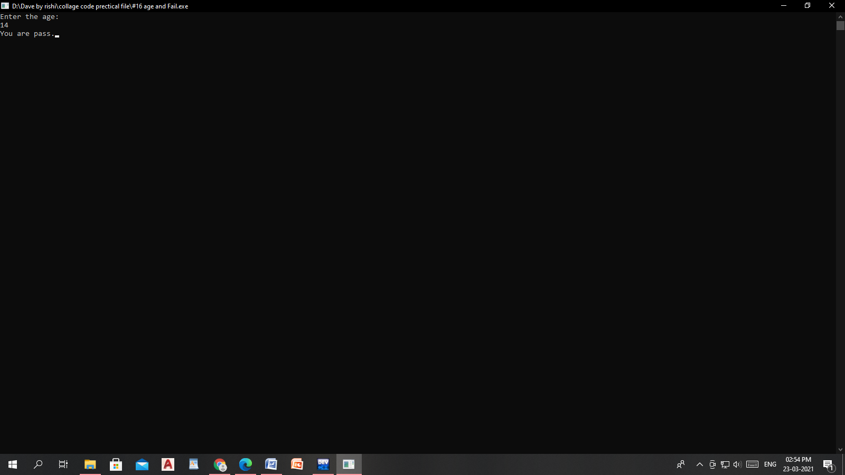

Question: 17

/*.....Wap to check given year is leap year or not?..........*/

#include<stdio.h>

#include<conio.h>

void main()

{

int a;

printf("Enter tha value of a");

scanf("%d",&a);

if (a%4==0)

{

printf("This year is Leap Year");

}

else

{

printf("This is not Leap Year");

}

getch();

}

Output:-

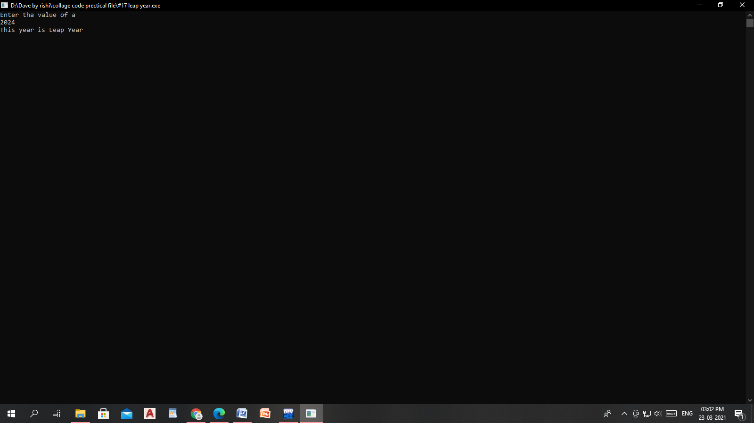

Question:-18

/*….WAP to show the use of conditional operator (Greater among two numbers)…*/

#include<stdio.h>

#include<conio.h>

void main()

{

int a,k,b;

printf("enter the value of a");

scanf("%d%d",&a,&b);

k=a>b?a:b;

printf("Gretest number=%d",k);

getch();

}

Output:-

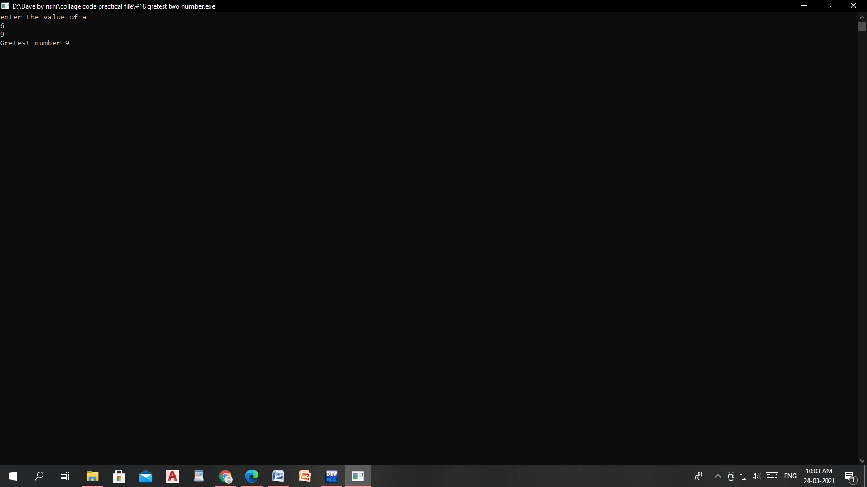

Question:-19

/*.....WAP to check whether the given number is even or odd (By using

Conditional operator..*/

Solution:-1

#include<stdio.h>

int main()

{

int a,b;

printf("Enter the value of a");

scanf("%d",&a);

(a%2==0)?printf("Even number"):printf("Odd number");

return 0;

}

Solution:-2

#include<stdio.h>

int main()

{

int a;

printf("enter the value of a");

scanf("%d",&a);

if(a%2==0)

printf("Number is Even");

else

printf("Number is Odd");

return 0;

} output:-

